Setup Overview

 | MACHINE TYPE  VF, MM, DM, DT, TM | Operation 1 / G54  4” Vise |  |  | PROGRAM #  O2001 | Material  3”x4”x1”
 |  |  | X0 Y0 in center of stock |  |  | Aluminum
TOOLS:
* - Denotes special tooling ** - Denotes special tooling setting instructions
USE | TOOL # | INSERT | TOOL | TOOL Holder | SET LENGTH | CRC
Face Mill | 1 |  | 1.5-2.0” Face Mill
Mill OD and Slot | 2 |  | .500” End Mill
Pilot drill holes | 3 |  | #7 / .201 drill
Chamfer holes and OD | 4 |  | .375 / .50” chamfer mill
¼-20 Tap | 5 |  | ¼-20 Tap

Setup notes

Work Holding Needed:
• One 4” or 6’’ Vise

Tools:
• 5 tool holders appropriate for your machine (1 shell mill, 4 ER collet chucks plus ER collets)

Material:
• Material type – Aluminum (multiple alloys acceptable. 6061 or 2024 recommended)
• Material size (Inch) - 3.0 x 3.0 x 0.75” or 1.0’’

Programs:
• Program number (Inch) O2001

Demo Descriptions
• This part is done in one operation with no backside work
• See pictures on instruction sheet for visual reference
• Tools may vary depending on your location and machine availability at your HFO. If there are any questions, please have an application engineer select an equivalent tool to the ones listed here.

Instruction sheet
• Load tools into machine per photo or NC Program file.
• Indicate vise square
• Use material as indicated on set up page
• Touch off all tool lengths
• Set G54 Z0 at stock face. Set G54 X0 Y0 in center of part
• Use program number O2001 to machine part.

Since our worldwide dealer network may have a variety of machines available to perform the test, specific tooling is not specified. Rather, an example tool is listed and it’s up to your engineers to find the equivalent tool for use on your specific machine based on tooling and machine availability. In most cases, slight variation in the tool size will not cause problems.

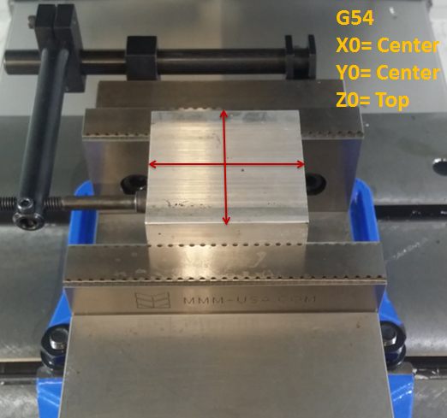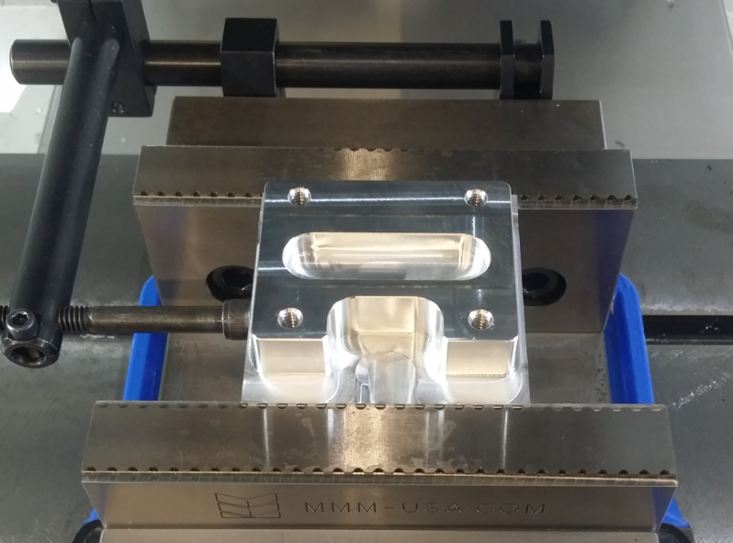

OP-1 OP-1 Completed

The following is an example tooling setup for VF-2 size machine.
Equivalent tools from any brand are acceptable.
Convert Inch to Metric equivalent as needed
Tool Number: 1  Face Mill | T1  Face Stock | 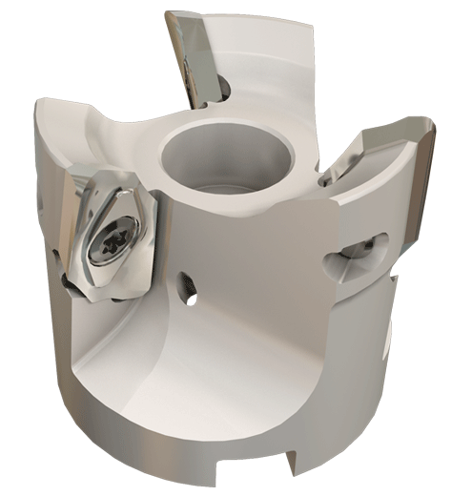  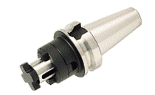  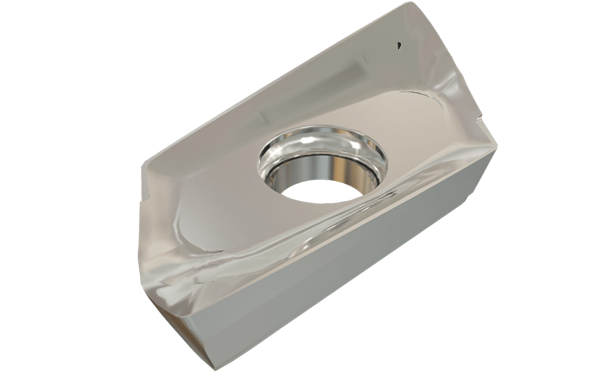
Holder Supplier  (for reference) | HM90 FAL-D2.00- .75-22  Face Mill
Insert Supplier:  (for reference) | HM90 APCR 220608R-P

Tool Number: 2  End Mill | T2  Mill OD and Slot | 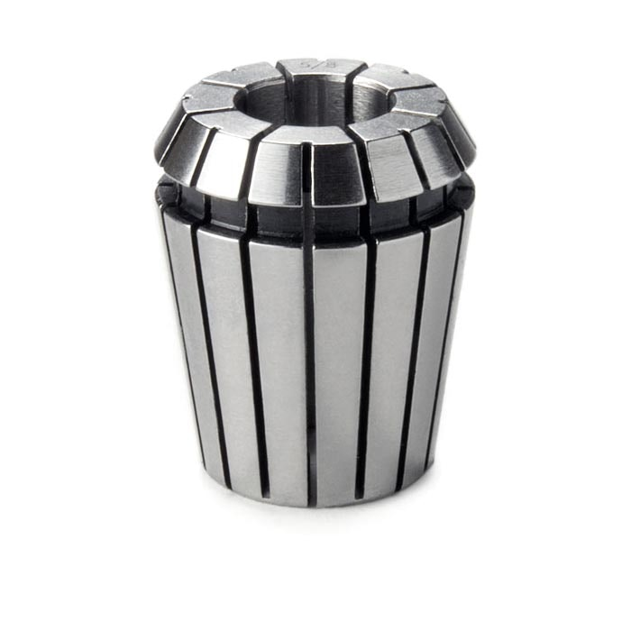  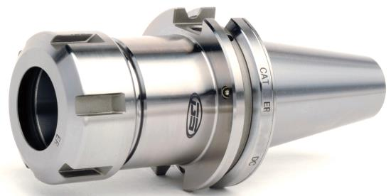  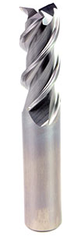
Tool Supplier  (for reference) | OSG 20424900  .500” / 12mm Endmill
ER Collet  (for reference) | 12-13mm Collet

Tool Number: 3  Drill | T3  Pilot drill for tap | 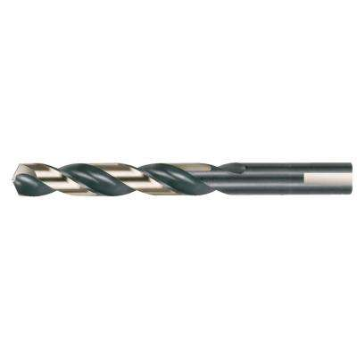
Tool Supplier  (for reference) | #7 Drill
ER Collet | 5-6mm Collet

Tool Number: 4  Chamfer tool | T4  Chamfer | 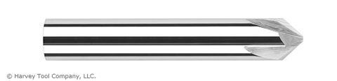
Holder Supplier  (for reference) | Chamfer Tool  .375”, .500”,
ER Collet | 9-10 or 12-13mm collet

Tool Number: 5 | T5  Tap | 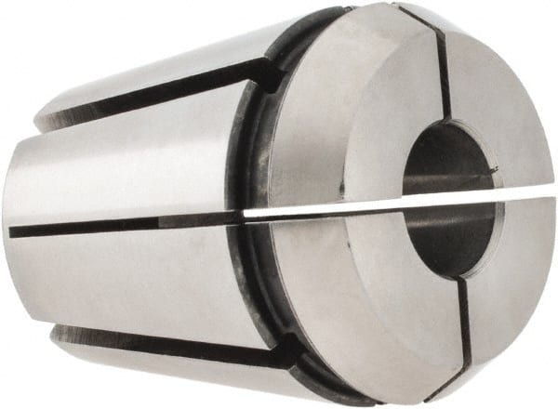  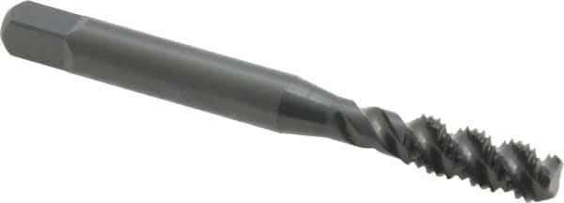
Holder Supplier  (for reference) | ¼-20 Tap
ER Tap Collet | 6-7mm Tap Collet

